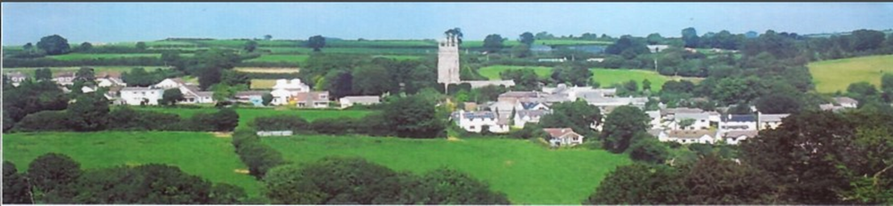

NORTH HILL PARISH COUNCIL ASSET REGISTER

**OFFICE EQUIPMENT**  Checked Value

HP Laptop 18.04.23 £479.98

Laptop Stand 18.04.23 £25.00

HP Printer/Scanner/Copier 18.04.23 £150.00

**COMMUNITY**

War Memorial 18.04.23 £2500.00

Telephone Kiosk North Hill 18.04.23 £1.00

Playing Field 18.04.23 £20,000.00

Play Equipment 18.04.23 £60,0000

Centenary Stone 18.04.23 £2500.00

Middlewood Notice Board 18.04.23 £350.00

Defibrillator North Hill 18.04.23 £1500.00

Bathpool Notice Board 18.04.23 £100.00

North Hill Notice Board x2 18.04.23 £200.00

Trebartha Notice Board 18.04.23 £100.00

Congdons Shop Notice Board 18.04.23 £100.00

Pump House at Congdons Shop 18.04.23 £1000.00

Octagonal Bench 18.04.23 £627.20

Disabled Picnic Bench 18.04.23 £396.05

Football Field 18.04.23 £15000.00

Salt Bins x 9 18.04.23 £1,000.00

Parish Bier 18.04.23 £500.00

Bus Shelter Congdon’s Shop 18.04.23 £800.00

Graveyard Area 18.04.23 £5000.00

Dog Bins x 8 18.04.23 £660.00

Berrio Bridge Notice board 09.05.24 £100.00

Coads Green Notice board 09.05.24 £100.00

Stocks in Church 09.05.24 £400.00

Defibrillator Bathpool 09.05.24 £3,348.00

Defibrillator Congdon’s shop 09.05.24 £1,500.00

Speed Camera 09.05.24 £2807.99

Telephone Kiosk, Coads Green 06.11.24 £1.00

|  |  |  |  |
| --- | --- | --- | --- |
| **DATE** | **AMENDMENT** | **AMENDED BY** | **MINUTE NUMBER** |
| 09/05/2024 | Added – 2 x notice boards / stocks /2 x defibs / speed camera | Full Council | 2024/10 |
| 04/11/2024 | Added – 1 dog bin, 1 salt bin, 1 telephone kiosk | Full Council | 2024/48 |